Cagaoan, Crischin Charm C. December 4, 2019

2ECE-C

DATA WRANGLING

Problem 1:

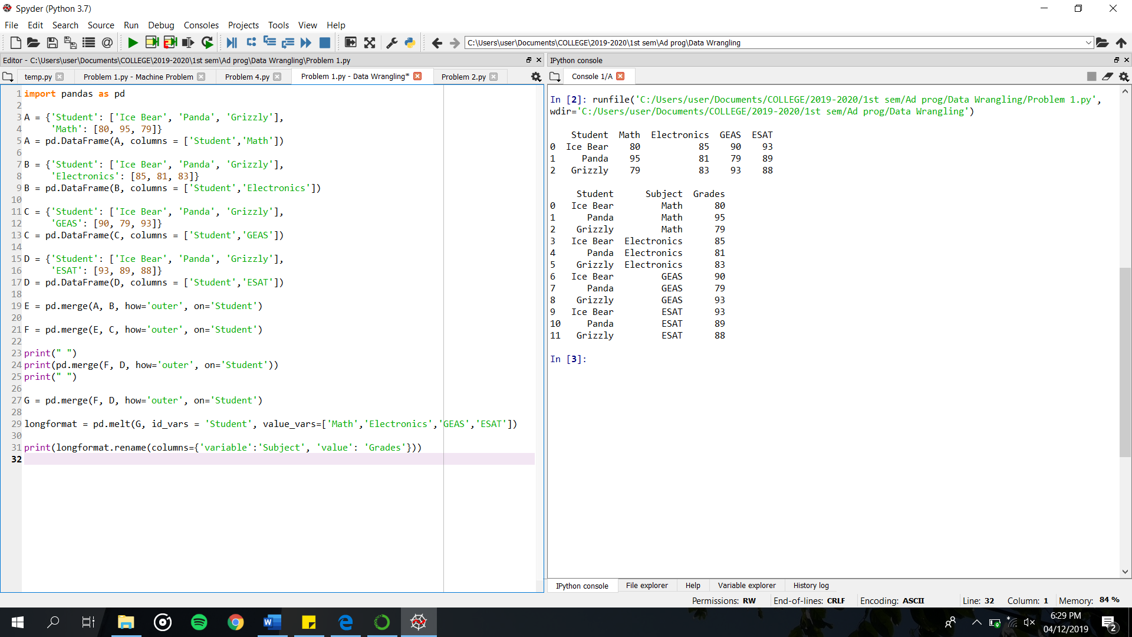

Problem 2:

